**Ideation Phase**

**Define the Problem Statements**

|  |  |
| --- | --- |
| Date | 29 June 2025 |
| Team ID | LTVIP2025TMID58951 |
| Project Name | Docspot: Seamless Appointment Booking For Health |
| Maximum Marks | 2 Marks |

**Customer Problem Statement Template:**

Booking a doctor's appointment has never been easier. With our convenient online platform, you can quickly and effortlessly schedule your appointments from the comfort of your own home. No more waiting on hold or playing phone tag with busy receptionists.

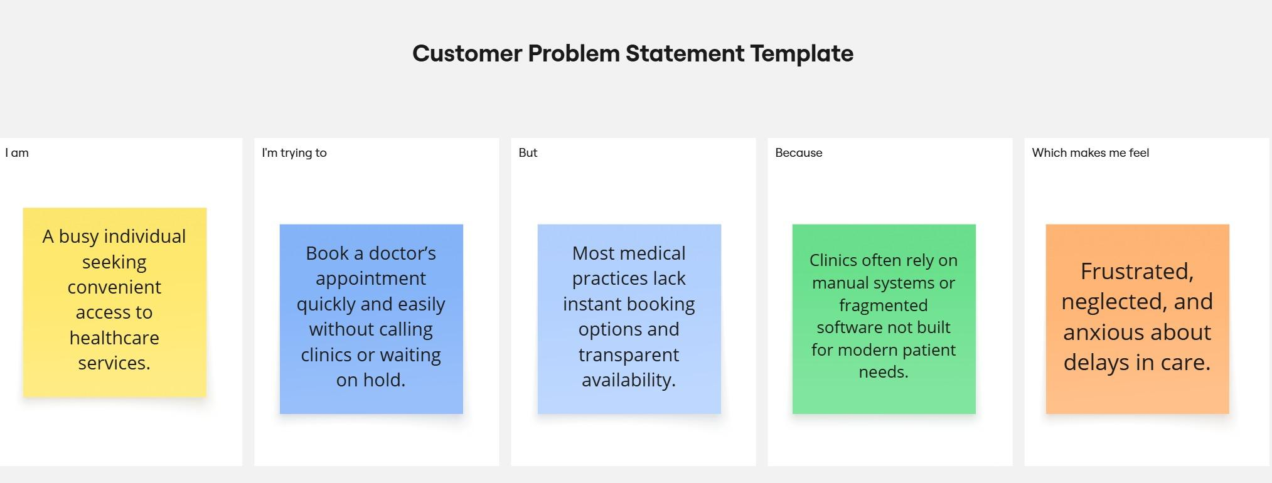

Reference: <https://miro.com/templates/customer-problem-statement/>

|  |  |  |  |  |  |
| --- | --- | --- | --- | --- | --- |
| **Problem Statement (PS)** | **I am (Customer)** | **I’m trying to** | **But** | **Because** | **Which makes me feel** |
| PS-1 | a working professional with a tight schedule | book a doctor’s appointment quickly without phone calls or long wait times. | most clinics don’t have real-time booking systems or clear availability info | their systems are outdated or fragmented | frustrated and anxious about my health getting worse while waiting. |
| PS-2 | a general physician running a small clinic. | manage patient bookings efficiently and reduce no-shows. | my current tools are manual or not tailored to healthcare workflows. | I can’t afford or understand complex clinic management systems. | stressed and underpaid despite my busy schedule. |